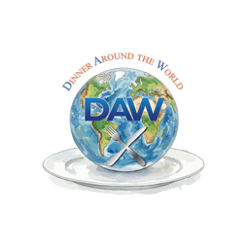
Dinner Around the World (DAW)
Terms of Service
Effective Date: 4/26/2026
Welcome to Dinner Around the World (DAW). By accessing or using our website and services, you agree to these Terms of Service (“Terms”).

1. Use of Our Services
DAW provides a platform to plan, host, and share international dinner experiences.
By using our services, you agree to:
- Use the platform for personal, non-commercial purposes
- Provide accurate information
- Respect other users and the community
You must be at least 13 years old to use our services.

2. Accounts
To access certain features, you may create an account.
You are responsible for:
- Keeping your login information secure
- All activity under your account
We may suspend or terminate accounts that violate these Terms.

3. Subscription & Payments
DAW offers:
- A free 3-month trial
- Then $39/year per group
By subscribing, you agree that:
- Fees are billed annually after the trial period
- Payments are non-refundable unless required by law
- You may cancel at any time (access continues through your billing period)

4. User Content
You may submit content such as:
- Photos
- Recipes
- Comments
By submitting content, you:
- Grant DAW a non-exclusive, royalty-free license to display and share it
- Confirm you have the right to share it
We may remove content that:
- Is inappropriate
- Violates laws
- Infringes on rights

5. Community Guidelines
You agree not to:
- Post harmful, offensive, or illegal content
- Harass or harm other users
- Misuse the platform
We reserve the right to remove content or restrict access if guidelines are violated.

6. Intellectual Property
All DAW content (excluding user submissions), including:
- Branding
- Design
- Features
…is owned by DAW and may not be copied or used without permission.

7. Service Availability
We aim to provide a reliable experience, but:
- Services may be updated, modified, or discontinued
- We do not guarantee uninterrupted access

8. Limitation of Liability
DAW is provided “as is.”
We are not liable for:
- Any indirect or incidental damages
- User interactions or experiences
- Loss of data or content

9. Termination
We may suspend or terminate access if:
- You violate these Terms
- You misuse the platform
You may stop using the service at any time.

10. Changes to These Terms
We may update these Terms from time to time.
Continued use of the service means you accept the updated Terms.

11. Governing Law
These Terms are governed by the laws of:
California/U.S.

12. Contact Us
If you have questions about these Terms:
📧 julie@dawfriends.com
🌐 dawfriends.com

